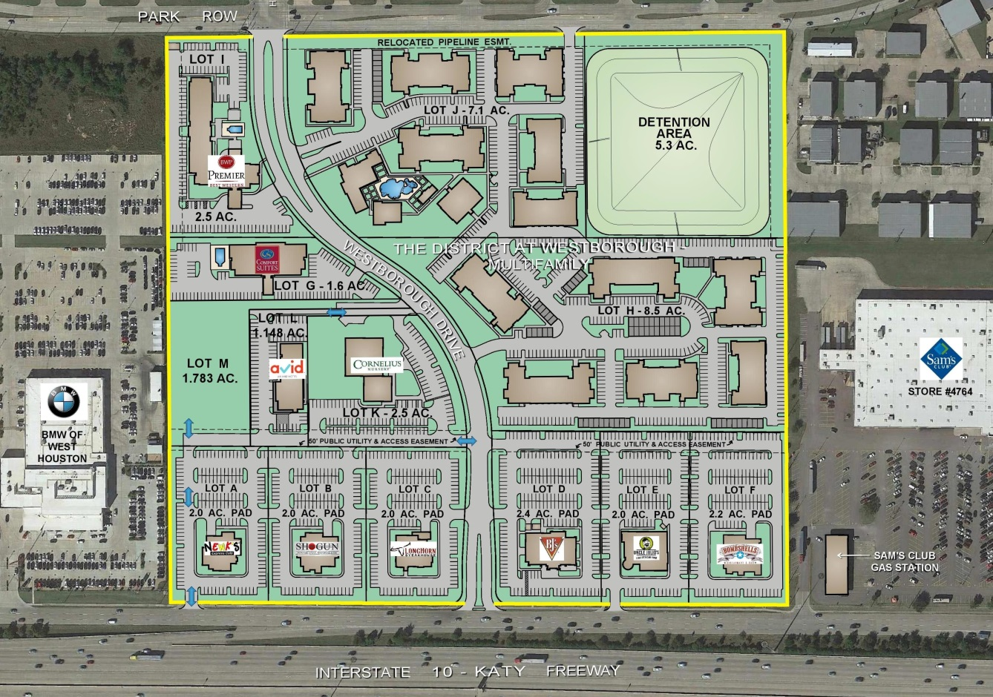
Prime Katy Location on Interstate 10
between Westgreen Blvd. and Fry Road – 45.7 Acre Tract

Last Remaining Available Lot:
- Lot M – 1.783 acres – for sale – with direct access to Westborough Drive and
I-10 Feeder Road
Existing Lot Users:
- Lot A – 2.0 acres – Newk’s Eatery
- Lot B – 2.0 acres – Shogun Japanese Grill & Sushi Bar
- Lot C – 2.0 acres – Longhorn Steakhouse
- Lot D – 2.4 acres – BJ’s Restaurant – Brewhouse
- Lot F – 2.2 acres – Bombshells Restaurant and Bar
- Lot E – 2.0 acres – Uncle Julio’s Mexican Restaurant
- Lot G – 1.6 acres – Comfort Suites Hotel (future development)
- Lot H & J – 15.6 acres – The District at Westborough – Multi-Family
- Lot I – 2.5 acres – Best Western Premier Hotel
- Lot K – 2.5 acres – Cornelius Nursery
- Lot L – 1.148 acres – avid – An IHG Hotel (future development)

